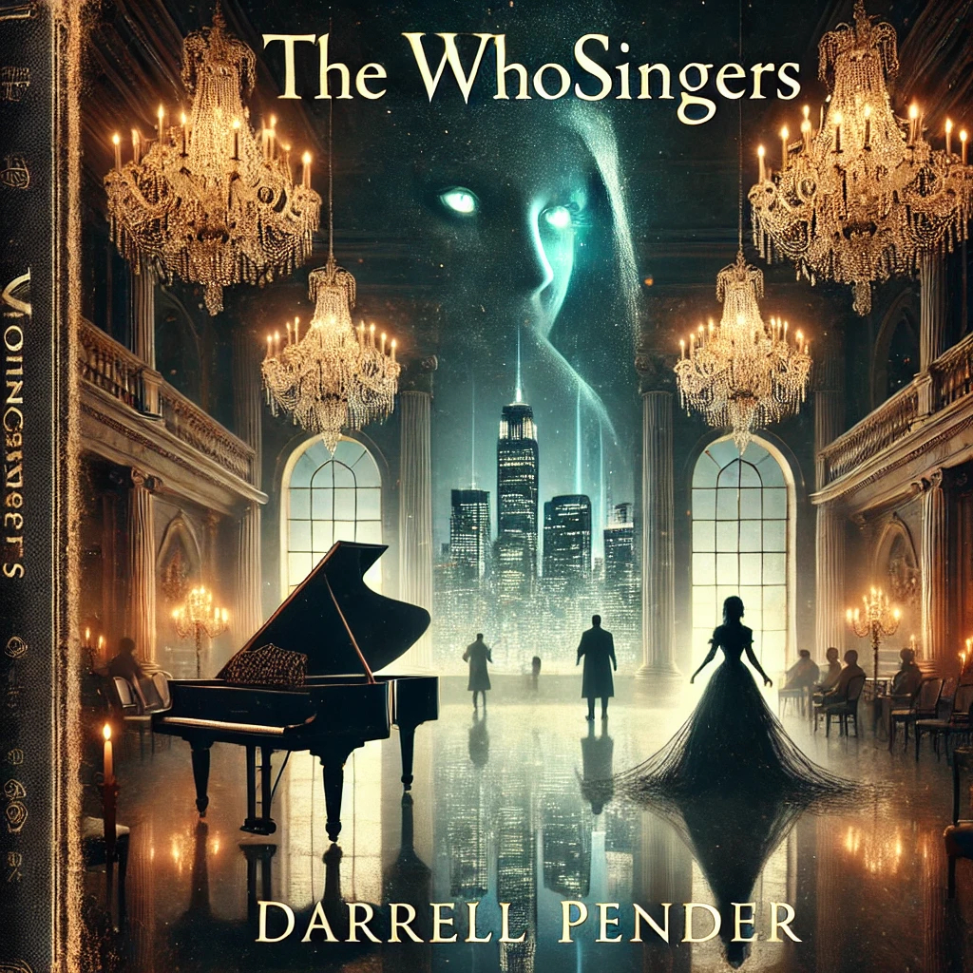
The Whosingers

By Darrell Barrow
©10/15/2001

Contents
The Whosingers 1
Chapter 1: The Poisoned Melody 4
Character Profile 12
Name: Isabella Blackwood 12
Name: Mark Whosinger 13
The Whosingers Outline 14

Chapter 1: The Poisoned Melody

The ballroom sparkled under the gentle glow of chandeliers, their crystals twinkling across the marble floors. Gilded mirrors lined the walls, reflecting the sophistication of elegantly dressed guests who glided like a sea of muted pastels. In 1798, a lively ball was in full swing at the heart of this grand estate, nestled in the rolling English countryside.
Soft conversations and the clink of crystal glasses created a murmur that wove through the orchestra’s lilting classical music.
Mark Whosinger, an accomplished pianist and composer, was among the few Black men at this high-society gathering. His wealth and talents had earned him entry, but his passion for music commanded respect. He was accustomed to performing at such events, yet tonight he was merely a guest-a guest among predators. Tall and composed, he embodied refined grace. His long, intricately braided hair fell just below his shoulders, brushing the rich fabric of his dark emerald waistcoat. His hazel eyes, striking against his smooth ebony skin, swept the crowd before settling on the grand piano that dominated the room’s far end.
The music called to him.
Mark had established his reputation not only for his wealth or status but also for his brilliance as a composer and pianist. Tonight, however, he wasn’t here to perform. He was here as a guest—a rare occurrence for a man of his talents, since his performances usually commanded the room. But tonight was different. Tonight, someone else would take the keys.
Isabella Blackwood approached him from across the room, her slender figure gliding through the crowd as if untouched by the world. Her eyes—pale green, almost unnaturally so—locked onto his with an intensity that sent a chill down his spine. She was a woman of mystery, shrouded in rumors and whispers, yet her beauty and charm masked the darkness beneath.
Mark felt a faint tug on his sleeve as he approached the piano. He turned to see her: Isabella Blackwood, the very woman who had vanished from society years earlier, her return now sparking rumors once more. Her ice-blue gown hugged her tall frame, and her piercing eyes, an unsettling pale green, fixed on him.
“I can’t help but notice,” she continued, her voice barely above a whisper, “that the piano awaits its master. Would you indulge me in a duet?”

Her lips curved into a smile, but it never reached her eyes. Mark had played with her once before, years earlier, and even then, something about her had unsettled him. The way she manipulated the music, almost as if she could shape reality through sound, left a haunting impression on him.
He nodded politely, though his instincts screamed at him to be cautious. They had played together once before, years earlier, and even then, something about her had felt dangerous. Yet tonight she seemed different. More potent. More deliberate. Yet here she was, gracefully reintroduced to society, moving through the room with elegance and poise.
Mark hesitated. The last time they played, Isabella’s performance had been unearthly, as if she could manipulate the very soul of the instrument. He had been drawn in then, as he was now—a sense of intrigue and danger swirling around her.
Before he could respond, she was already at the piano, her long fingers resting lightly on the ivory keys. She glanced back at him, challenge in her eyes.
Mark took his place beside her. The room fell silent as they began to play, and the guests gathered nearby to watch the impromptu duet. The melody they created was hauntingly beautiful, weaving together in a way that seemed to transcend time itself.
Yet something felt off. There was an undercurrent in the music, a dark tone Mark couldn’t place. Isabella’s playing led the music into unfamiliar territory—sharp dissonances that unsettled the soul.
She paused as they neared the crescendo, leaning in closer to him, her breath warm against his ear.
“Do you know why I returned, Mark?” she whispered.
His fingers hesitated over the keys. He turned his head slightly, sensing her presence.
“To poison your future,” she said, her voice low and menacing.
Before he could react, a sharp pain gripped his chest. Mark gasped, his fingers faltering on the keyboard. His heart raced, and his vision blurred. He tried to stand, but his legs wobbled beneath him. Isabella’s cold laughter echoed in his ears. When he turned to face her, she was already slipping into the crowd, her pale green eyes gleaming with triumph.
He clutched the piano as the weight of her words and their venom sank into him. The ballroom spun, faces and voices fading into shadows. His strength waned as the poison coursed through his veins, but Mark Whosinger was not ready to die—not yet.
Gritting his teeth, he forced himself to stand, legs unsteady yet determined. Isabella was not going to escape. Not this time.

He staggered through the ballroom, pushing past startled guests as he followed the faint glimpse of her blue gown. Isabella slipped through a side door, vanishing into the night. Mark pursued her, each step a struggle against the poison that threatened to drag him into unconsciousness.
The cool night air did little to clear his mind. The cobblestones beneath his feet blurred as he stumbled after her. She darted into an alley, a chuckle of delight escaping her lips. Mark approached cautiously. As he turned into the alley, he saw a strange shimmer—a distortion in the air. The 18th-century architecture seemed to ripple, replaced by towering modern buildings. The alley now led to a music store, its windows displaying sheet music for genres he had never seen.
Isabella slipped through the shimmer and stood inside the store, rifling through a collection of compact discs. Mark’s heart pounded as adrenaline temporarily pushed back the poison. He had little time left, but he wouldn’t allow her to escape.
Mark stepped through the shimmer with a burst of energy and found himself inside Carl Fischer Music. Isabella was too absorbed in her search to notice him behind her. Mark stepped closer, his voice rough. “Isabella.”
She froze, her fingers halting mid-motion. Slowly, she turned to face him, her eyes widening in surprise—and, for the first time, in fear.
“How did you—?” she began, but Mark interrupted.
“I’m not finished with you yet,” he growled, his chest heaving from the effort of speaking.
Isabella’s eyes darted around the store, searching for an escape, but there was nowhere to run. Not now. Not here. Mark wasn’t going to let her slip through his fingers again.
But the poison was taking its toll. His vision dimmed at the edges, and his knees threatened to buckle beneath him. Time was running out.
Isabella’s lips curled into a smirk again. “It doesn’t matter, Mark,” she said softly, stepping back toward the exit. “You’re already dead.”
She bolted for the door. Mark reached into his coat and pulled out a piece of paper he had taken from his study just before the ball—a police department report. It contained all the evidence he had gathered over the years on the mysterious woman who had poisoned several wealthy men across Europe. The fingerprints, signatures, and accounts all pointed to one person: Isabella Blackwood.
“Run all you want,” Mark whispered, clutching the paper. “But I’ll find you, no matter where or when.”
The world around him kept shifting between the past and the present as he fell to the floor.
Several days later, Mark awoke to the sterile hum of machinery and the faint antiseptic scent that clung to the air. His eyelids felt heavy, as if weighed down by unseen forces, but he forced them open. Harsh fluorescent lights bathed the room in an unnatural glow, and he squinted, trying to make sense of his surroundings.
This was neither his room nor his world.
Mark’s breath caught in his throat as he took in the scene around him. He lay in a narrow hospital bed, covered with crisp white sheets. Transparent walls enclosed him in a small isolation booth. A thin curtain hung at one side of the enclosure, drawn back to reveal a larger room beyond. People in strange, modern attire—white coats and scrubs—moved with purpose, tapping on handheld devices or speaking in low, urgent tones. Machines blinked with lights that seemed to serve no discernible purpose.
Where am I? His mind raced as his body felt sluggish, weighed down by the lingering effects of the poison.
A low beep sounded beside him, and he turned his head with great effort. A thin tube attached to his arm fed into an IV drip. The clear liquid flowed steadily into his veins, while a monitor beside the bed blinked with symbols he could not recognize.
This was not England. His thoughts spiraled, disoriented, as he tried to piece together what had happened. The last thing he clearly remembered was pursuing Isabella through a strange shimmer; time seemed to warp into what looked like a completely different world.
He blinked hard, pushing through the fog clouding his mind, then tried to sit up. His muscles, weakened by days of inactivity, protested violently, and he collapsed back against the pillow with a frustrated groan.
A soft chime echoed from the doorway, and moments later, a woman entered. She wore a white lab coat over dark scrubs, her hair tied back in a neat bun. Her expression was calm yet guarded, and her gaze widened slightly when she saw he was awake.
“You’re awake,” she said, her voice steady, though a hint of surprise remained in her tone. “We didn’t expect you to regain consciousness for another few days.”
Mark frowned in confusion. Although he understood her English, her accent sounded strange, clipped, and rapid, unlike anything he had ever heard.
The woman stepped closer, pulled a small device from her coat pocket, and tapped it. “How are you feeling? Any dizziness or pain?”
Mark stared at her, trying to make sense of his surroundings. His lips were dry, yet he forced out a hoarse whisper. “Where... am I?”
The woman paused, her brow furrowing slightly as she glanced at the monitor beside his bed.
“You’re at New York-Presbyterian Lower Manhattan Hospital,” she said, as if that would explain everything. “You were found unconscious on the floor at Carl Fisher Music Store several days ago and brought in. Do you remember anything about what happened?”
New York and Manhattan meant nothing to him.
He blinked, trying to make sense of it all. “I... was pursuing someone. A woman. She... poisoned me.”
The doctor’s eyes narrowed slightly, but she kept a neutral, professional expression. “You mentioned poison when you first arrived, but none of our tests detected anything lethal in your system.”
Mark stared at her, confusion blossoming in his chest. “It was poison,” he insisted, his voice weak yet determined. “I felt it. She... it was killing me.”
The woman nodded slowly, but doubt lingered in her expression. “Whatever it was, it doesn’t seem to be affecting you now. Your body fought it off. But I need to ask—do you remember who you are? Where are you from?”
He hesitated. “My name is Mark... Mark Whosinger. I’m a composer and a pianist.” He glanced around the room again, disoriented by the technology and the strange sounds in the air. “But this... this isn’t my time.”
The doctor furrowed his brow in confusion. “Not your time?”
Mark met her gaze as the weight of his realization settled in. “I was at a ball... in the English countryside. The year was 1798.”
The woman’s eyes widened as skepticism crept into her expression, though she stayed calm. “1798?” she repeated, trying to process what she had heard.
Mark nodded, feeling the disorientation intensify. “Yes. And the woman I was chasing—Isabella Blackwood—she did something. She poisoned me, and then... I don’t know how, but I woke up here.”
The doctor fell silent, tapping something into her tablet before speaking again. “Mr. Whosinger,” she said carefully, “you’ve been at New York-Presbyterian Lower Manhattan Hospital for several days. The authorities are investigating your case, but no records have surfaced for anyone named Mark Whosinger or Isabella Blackwood. You’re in the year 2024.”
Mark froze as the words crashed down on him like an avalanche. "2024?"
It was impossible; that was more than two centuries away.
The doctor, sensing his shock, softened her tone. “You were found unconscious on the street in Manhattan. You must have experienced something traumatic. You... you need to rest and recover.”
Mark’s pulse quickened, and his chest tightened. 2024. That meant... everything had changed. His world was gone. But Isabella—she had to be here somewhere. She was the only one who could explain what had happened.
“I need to find her,” Mark rasped, trying to sit up despite the dizziness. “Isabella Blackwood. She’s the key. I need to find her.”
The doctor gently touched his arm, urging him to lie back. “For now, Mr. Whosinger, you need to focus on recovery. We will continue investigating your case and contact the authorities again. Perhaps they can help locate the woman you’re describing.”
Mark knew better. No authority in this strange new world could truly understand what he had endured. But one thing was certain—Isabella Blackwood was out there and dangerous. He had to find her, no matter how long it took. Nothing would stop him if he could survive two centuries to find her again.
The machines' hum and the hospital's low chatter faded as Mark's mind raced. He tried to piece everything together, but the weight of two centuries was too much to grasp. His body ached, and his thoughts were clouded, yet one thing burned bright in his mind: Isabella.
He exhaled deeply and sank back against the bed. Exhaustion finally caught up with him, pulling him into a restless, uneasy slumber.
In the corridor outside his isolation booth, the nurse who had checked on Mark lingered just beyond the glass, arms folded across her chest. She watched him sleep, her brows furrowed with concern. The soft tap of footsteps echoed in the hallway, and moments later, Dr. Hughes—a middle-aged man with salt-and-pepper hair and a perpetual air of quiet authority—joined her.
“Is he stable?” Dr. Hughes asked, his voice low as he looked through the glass partition.
The nurse nodded. “Physically, yes. Vitals are stable. He’s still weak from whatever compound was in his system, but he’s on the mend.”
Dr. Hughes raised an eyebrow. “And what about the mental aspect?”
The nurse hesitated, glancing down at the tablet in her hands before looking back at her superior. “I’m not sure what to make of it. He’s coherent, at least in speech, but what he’s saying—about being from the 18th century, being poisoned at a ball, and chasing a woman named Isabella Blackwood—sounds completely convincing.”
Dr. Hughes let out a thoughtful hum, his gaze drifting back to the unconscious man in the bed. “Does he believe it’s real?”
“Absolutely,” the nurse replied. “I don’t think he’s lying, but it’s... delusional. He genuinely believes he’s from 1798, Doctor. He spoke about it as if it had just happened.”
Dr. Hughes rubbed his chin, a pensive expression on his face. “Could it be a side effect of whatever compound was in his system? Some hallucinogen?”
“We ran all the tests,” the nurse said, shaking her head. “Nothing matches any known toxin or drug. Whatever was in his system wasn’t normal. The fact that his body fought it off... It’s as if he’s immune to something we don’t yet understand.”
Dr. Hughes fell silent for a moment, contemplating the information. He took a deep breath before speaking again. “We will need a full psychiatric evaluation. If he’s experiencing delusions or hallucinations, we must understand the extent of them. And if he’s dangerous...”
The nurse shifted uneasily. “Do you think he could pose a threat?”
Dr. Hughes looked at her seriously. “He said he was poisoned. He was found unconscious on the street, with no ID or explanation, and now claims to be from the 18th century. That’s enough to warrant caution. We don’t know what trauma he’s experienced or whether there’s more to his story than we realize.”
The nurse nodded slowly, her fingers tightening around the tablet. “I understand. I will schedule the evaluation.”
She turned to leave, but Dr. Hughes's voice stopped her. “Keep an eye on him, Jane, and let’s make sure he’s secure. We don’t want him wandering off if he decides he needs to find this... Isabella.”
The nurse, Jane, nodded slightly before walking down the corridor, her footsteps echoing off the sterile floors. Dr. Hughes lingered, staring through the glass at Mark, who shifted in his sleep. He couldn’t shake the feeling that there was more to this patient’s story—something beyond mere delusion. Whatever it was, it would need to be handled with care.
Inside the isolation booth, Mark stirred, trapped in a half-waking dream. His mind remained filled with fragments of music and the fleeting image of Isabella's pale green eyes watching him from the shadows.
He blinked slowly, the shadows behind his eyes dissolving into the stark white of the hospital ceiling. The pale green of her gaze lingered in his mind like a distant, unresolved chord.
Mark turned his head slightly, his muscles stiff from disuse. The IV tugged at his arm, a cold reminder that he was still tethered to this time, this place, and this reality that didn’t belong to him.
He tried to sit up again, gritting his teeth against the effort. The world swayed, but he stayed steady this time. A window lay to his right. Through the glass, the city pulsed—a restless, glittering expanse of steel and noise—so different from the tranquil hills of home.
He leaned back against the pillow, his chest rising and falling slowly and deliberately. Nearby, a machine beeped at regular intervals—alien and precise. Too precise.
He closed his eyes for a moment.
Was she here?
Not in this room. Not in this time. And yet…
There was a pull in his chest. Not pain. Something else.
He opened his eyes again and let them wander across the ceiling tiles until they reached the glass wall's corner. Movement.

Character Profile

Name: Isabella Blackwood
Background: Isabella was born into a wealthy family in the 19th century. Despite her privileged upbringing, she was never content with the restrictions placed on women in society and longed for independence and power. As she grew older, Isabella became increasingly fascinated with dark magic and the occult, delving into the forbidden arts.

Motivation: Isabella's ultimate goal is to gain immortality and wield absolute power over time and space. To achieve this, she has resorted to nefarious means, including murder, theft, and manipulation. When she encounters Mark Whosinger and his mysterious piano, she sees an opportunity to fulfill her darkest desires.

Role in the Story: Isabella is one of the story’s main villains. She is responsible for poisoning Mark Whosinger and manipulating events across time and space to further her goals. She is cunning, ruthless, and utterly devoted to her agenda, willing to do whatever it takes to achieve her ultimate aim.

Name: Mark Whosinger
Background: Mark was born into a middle-class African American family in the 1770s. Growing up, he showed a natural talent for music, especially the piano, which he pursued passionately. His family supported his musical ambitions, and he went on to study at Berklee College of Music, a prestigious institution in Boston, where he honed his skills and developed a unique style that blends classical and contemporary influences.

Appearance: Mark is a tall, well-built man in his mid-30s. His long braids and hazel eyes convey his intensity and passion for music. He dresses stylishly and modernly, often wearing colorful clothing that reflects his personality and creative spirit.

Role in the Story: Mark is the story’s protagonist. This talented and accomplished musician becomes the victim of a nefarious plot by Isabella Blackwood, a dark sorceress seeking to control time and space. Despite his challenges, Mark remains determined to uncover the truth and protect the people he loves, using his musical talents to navigate time and space in pursuit of justice.

The Whosinger’s Outline
It is a story about Mark Whosinger, who was poisoned by Isabella Blackwood and escaped into the future by a freak mishap, which opens a music shop in a mall.
- Mark was born in the 18th century
- Relatively wealthy and lives in a vast home
- Accomplished Musician, writer, and pianist
    - [Character] plays piano with Mark
    - The piano is not a regular piano. A piano, before the modern piano, is what we know it to be
    - [Character] asked to bring back the disk for the piano for recording and playing later
    - [Character] enters through a door and is instantly transported to the present inside Bay Harbor Mall
    - [Character] finds a music shop that sells the disk he was sent for. The store attendant says she must look for the items and walks down the hall.
    - [Character], recalling that she looks vaguely familiar, follows.
    - [Female Character] enters a room
    - [Character] waits to see what happens, and she does not return.
    - [Character] enters through the door to find himself in the past, across from the shop he was first trying to find.
    - Upon entering the shop, he finds [Female Character] busy trying to find a disk. She looks up in surprise.
    - [Character] questions her about the cost of the disk. She replies that they are $1, but only at this time, and tries to escape.
    - [Character] pulls out a piece of paper stating that it was a report from the police department with fingerprints and data about a killer who had gotten away many years ago.
    - [Character] offers that if she sells the disk at $1, he will hold it for one month and not release it, claiming that she poisoned Mark Whosigner.

